Hotel information & Reservation
- Hotel Information (presentation slides):
- Hotel Reservation
The conference has negotiated with the following hotel for the participants. All the WISE 2016 attendees will be offered with special hotel rates. Please fill out the Hotel Reservation Form and send it by email to reservations@crowneplazafudan.com (cc to wise.conf@gmail.com). The deadline for hotel reservation with the conference rates is Oct 5th, 2016.

Hotel Name | Address | Room type | Price | Including
Crowne Plaza Shanghai Fudan | 199 Handan Road Shanghai PRC | Superior Twin Room | 800 CNY per night | 2 single beds, breakfast for 2 persons
Crowne Plaza Shanghai Fudan | 199 Handan Road Shanghai PRC | Superior King Room | 800 CNY per night | 1 king bed, breakfast for 1 person

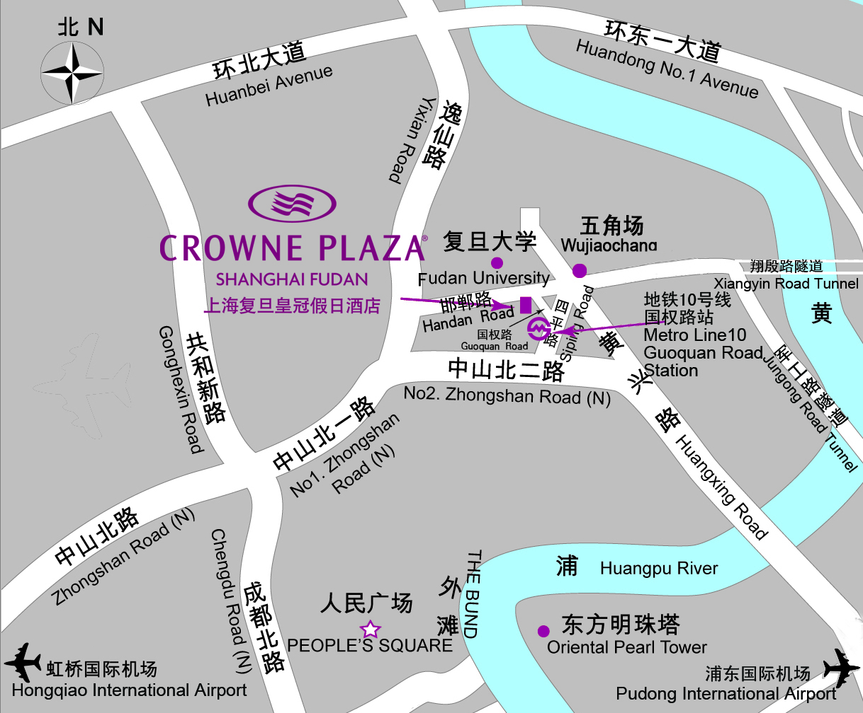
Google map of the hotel

Hotel Name | Address | Telephone
Fuxuan Hotel | 400 Guoding Road, Shanghai | (86)021-55589518
Fudan Yanyuan Hotel | 270 Zhengtong Road, Shanghai | (86)021-65115121
Fortune Hotel | 399 Handan Road, Shanghai | (86)021-65110000
Near the conference place, there are many hotels you can choice. The following hotels are recommended, but there are no conference discounted rates. You can book room directly by phone.

